

**Faculty of Arts and Sciences**

**Department of Computer Science**

CMPS 299 – Software Engineering

Spring 2016

Mentor: Dr. Ahmad Dhaini

**Software Project Documentation**

|  |  |
| --- | --- |
| Class Section | 4 |
| Project Name | AUB Kiosk |
| Team Name | AUB Kiosk Team |
| Team Members | Sarah Fakhoury- Samer AL Masri - Ines Badji |

**Table of Contents**

1. Introduction
   1. Project Overview
   2. Project Scope
   3. Product Features
2. Project Management
   1. Milestones:
      1. Revision History
      2. Schedule
      3. Responsibilities
   2. References
3. Technical Process
   1. Methods, Tools, and Techniques
   2. Software Documentation
   3. Testing and Quality Control
4. User Manual
5. Acknowledgments

# Introduction

## 1.1 Project Overview

AUB Kiosk is an application accessed via a touchscreen/kiosk, to be available for use by AUB visitors, students, faculty and staff at several points of interest around the campus. The application features an interactive 3D map of AUB’s campus (with realistic rendering of all buildings), designed to help users find their way around campus, or search for important information related to the university and its vicinity, such as places to eat (on and off-campus), places to study, people, specific buildings, classrooms and departments.

## 1.2 Project Scope

The scope of the project is divided into two sections. First of all the campus map feature is limited to the AUB campus and does not extend to the AUB medical center or the surrounding vicinity (bliss and hamra streets). Second of all, the ‘off campus’ feature is limited to a 2 to 3 kilometer radius around the campus, encompassing all places to eat, drink and study therewithin.

## 1.3 Product Features

* Realistic 3D rendering of all AUB campus buildings and terrain
* Search Bar
  + - Enables users to search for information about AUB instructors, Staff, Buildings, Study Places, Faculty, Departments, Paperwork, Special Places
* Pins
  + - Pop up pins that mark notable locations on campus like vending machines, cafeterias, libraries, atms, and housing facilities.
* Study On Campus
  + - Allows users to find empty classrooms on campus that they can currently study in.
* Off Campus
  + - Enables users to find the location and information about places to eat around AUB.
* Path
  + - This feature helps users find their way around by plotting out paths from the kiosk to other buildings.

## **2. Project Management**

## 2.1 Milestones

2.1.1 Revision History

|  |  |  |  |
| --- | --- | --- | --- |
| **Version** | **Date** | **Update Comments** | **Author / Updated By** |
| 1.0.0 | February 21 2016 | First Revision | AUB Kiosk Team |
| 1.0.1 | March 18 2016 | Second Revision | AUB Kiosk Team |
| 1.0.2 | March 20 2016 | Third Revision | AUB Kiosk Team |
| 1.0.3 | March 28 2016 | Fourth Revision | AUB Kiosk Team |
| 1.0.4 | April 9 2016 | Fifth Revision | AUB Kiosk Team |
| 1.0.5 | April 20 2016 | Sixth Revision | AUB Kiosk Team |
| 1.0.6 | April 22 2016 | Seventh Revision | AUB Kiosk Team |
| 1.0.7 | May 9 2016 | Eighth Revision | AUB Kiosk Team |

## 2.1.2 Schedule

## Goal of each meeting:

## Seeing the evolution of each team member and helping if the person is facing some kind of bugs/difficulties with the task.

## Learning what each team member is doing to be able to continue the work.

## In each meeting we will teach each other the “Discoveries” that each one made.

## Saturday meeting will be for integrating/testing and fixing

## January Meetings: Brainstorming, deciding on the different software to use.

|  |  |
| --- | --- |
| Date | February |
| 2nd & 4th | Getting accustomed to the different softwares individually. |
| 6th | Dividing the work.Creating BitBucket accounts.Updating the documents.Thinking about the different features.Learning how to code for touch and click on unity.Making sure that buildings are imported well to unity.Starting to build the UI. |
| 9th | Show database DesignPut prebuilt buildings in bitbucketChecking/creating UI design |
| 12th | Shared the evolution on each team member and concerns or problems we were facing. |
| 14th | Working on the UI Design.Tried importing all buildings already made to a shared map.Making sure that the information in the database where consistent with out needs. |
| 16th | Fixing the mockups.Working on the click feature.Fixing buildings. |
| 18th | Color on ClickUI design |
| 20th | UI designFixing buildings |
| 21th | Puting the prototype together (6h) |
| 23th | Fixing UI |
| 27th | Changing UIAdding touch motionWorking on Documentation |

|  |  |
| --- | --- |
| Date | March |
| 1st | Discussion on the changes to makeDocumentationChanging UI |
| 3rd | Fixing Database |
| 6th | UI design |
| 7th | UI designLinking database to projectFixing Database |
| 13th | UI fixesDatabase parsing |
| 20th | Working On DatabaseAdding details |
| 25th | ReschedulingWorking on UI (Finish Linking database, camera sliding to building on double touch) |
| 26th | Pins on buildingsReload game after certain period of timeLimit ZoomDouble touch |
| 27th | Fixing pinsMaking camera not go through buildingsAdding “Go to” button on building search |

|  |  |
| --- | --- |
| Date | April |
| 9th | Deciding on levels position for lower campus and dividing work for demo. |
| 16th | Finishing buildings and map terrains.Working on study places. |
| 23th | Adding pins and buildings coordinatesFixing camera scriptWorking on TerrainIntegratingFormating search results |
| 30th | Changing camera codeFiguring out pathWorking on off campusBuildings off campusFixing bugs discovered during demo |

## 

|  |  |
| --- | --- |
| Date | May |
| 9th | DocumentationIntegration of camera code and off campusWorking on paths |

## 2.1.3 Responsibilities:

## 2.2 References

* Unity Tutorials: <https://unity3d.com/learn/tutorials>
* Fixing problems: [stackoverflow.com](http://stackoverflow.com)
* AUB Facilities planning and design unit.
* AUBsis
* AUB Archives
* Restaurant information: <https://www.zomato.com/>

# Technical Process

## 3.1 Methods, Tools, and Techniques

|  |  |  |
| --- | --- | --- |
| Hardware | Software | Languages |
| * Razor Laptop 15” (Intel i7) * Dell S2240t 21.5” full HD touch screen * Windows Surface 3 Pro * 40” screen. | * SketchUp Pro Trial Version 16.0.19912 64-bit * Blender Version 2.76 * Unity Version 2.3.2f Personal * Microsoft Visual Studio Community 2015 * MySQL workbench * Notepad ++ * Google drive * Bitbucket * Windows 7+ | * C# * Java * JavaScript * SQL |

## 

## 3.2 Software Documentation

In code commentation, this document (including the user guide).

## 3.3 Quality Assurance and Control

**Quality assurance**: the AUB Kiosk team had frequent meetings to make sure the team is doing the right thing.

**Quality control**: We will be collaborating to test all our codes and make sure we deliver a bug free application.

# User Manual:

**Use case 1:** Getting more information about a building appearing on the map:

The user double taps the building, and the name of the building will pop up in a box.The camera is than panned to the front entrance of the building. The user can exit out of the box by clicking on it

.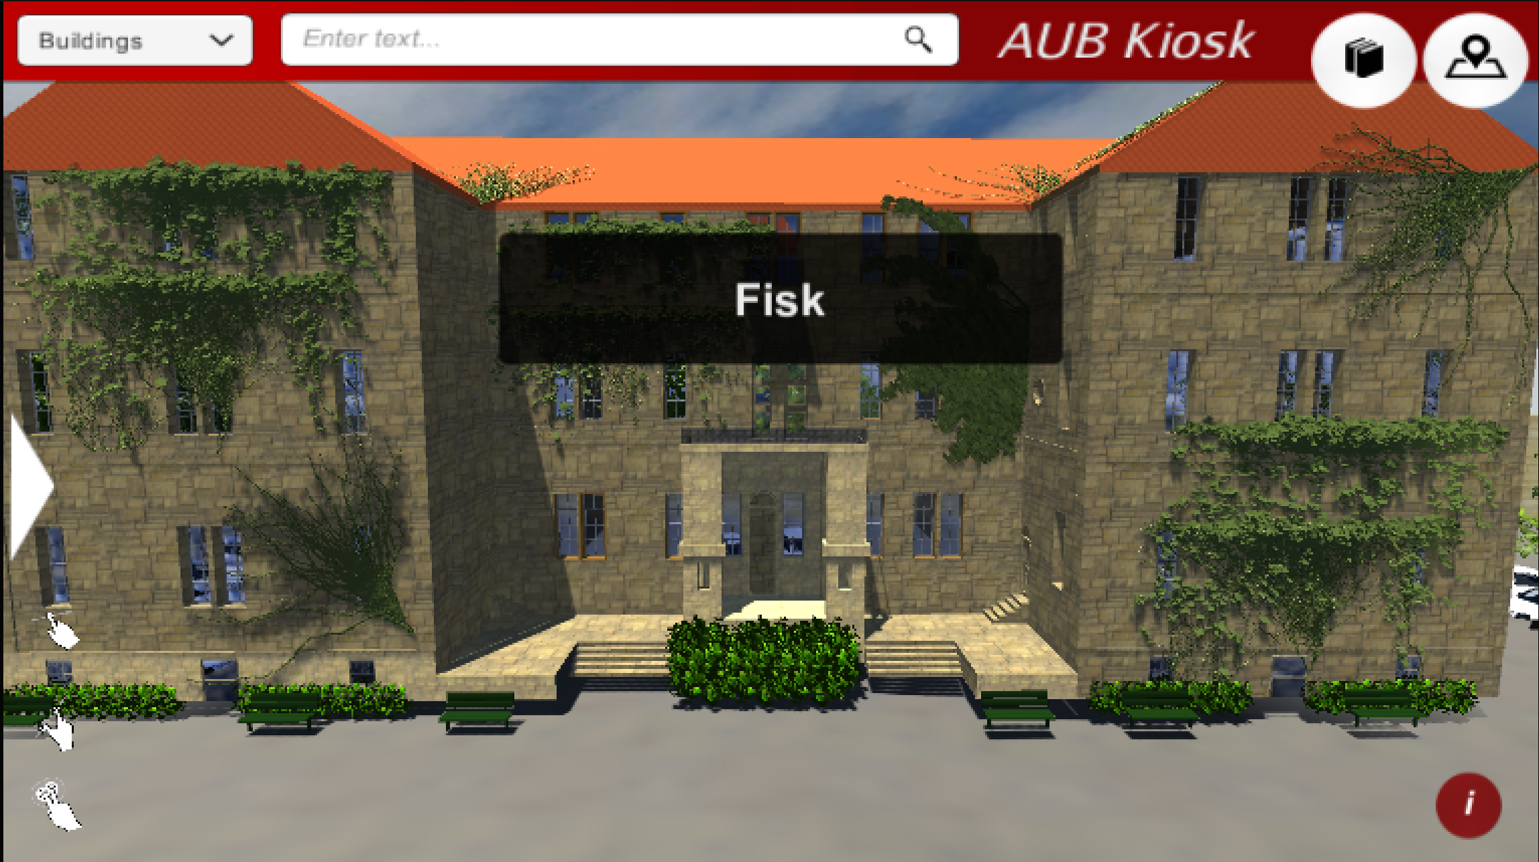

**Use case 2:** Search:

The user can search for specific information by touching the search bar (which will add a touch keyboard on the screen). Search results will pop up in a text box over the map. The default search is on buildings, which will take you to the building as well as giving information about it on the pop up box. By clicking on the drop down menu on the left side of the search bar, the user can filter their search result by instructor, staff, departments, faculty, special places and study places.

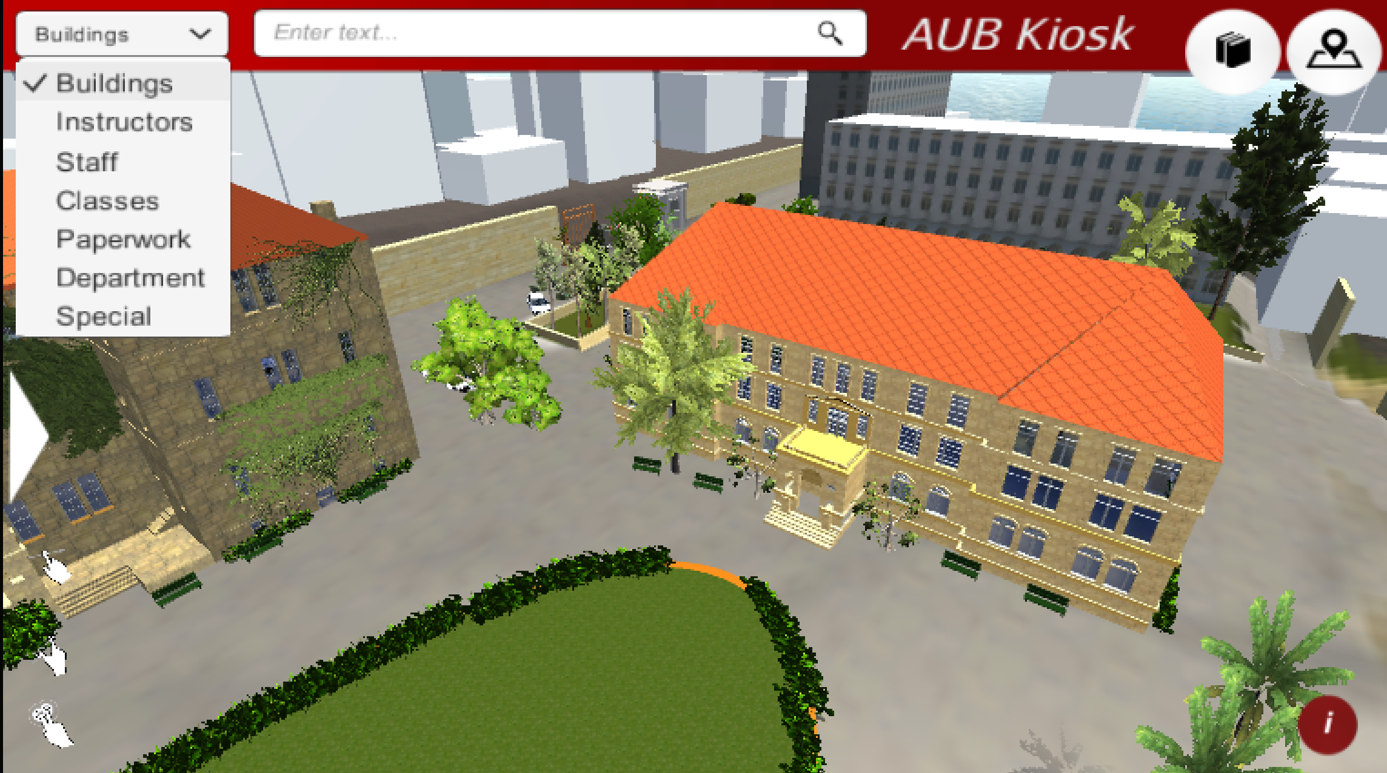

**Use case 3:** Paths:

The user can click on the road button which will show a drop down menu of different building names that the user can select to find a path from the kiosk to that building. The camera will zoom out showing a highlighted path.

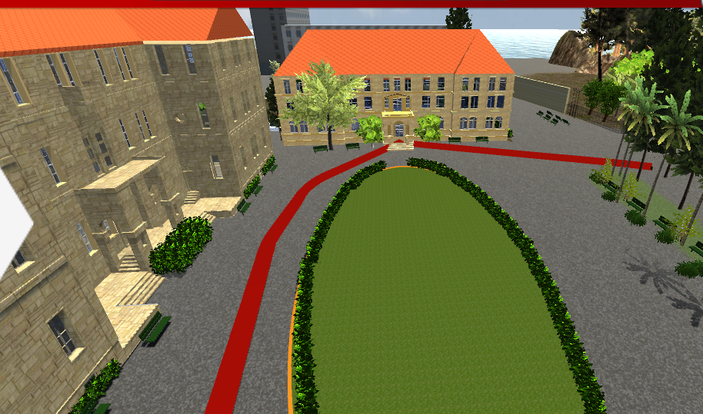

**Use case 4:** Pins:

To find notable places around campus, the user can click on the way point button. A drop down menu will allow them to toggle different way points that appear above buildings. Some examples of way points are cafeterias, libraries, housing facilities. The camera will zoom out to show the entire campus when toggled. The user can toggle off the pins by clicked them once more.

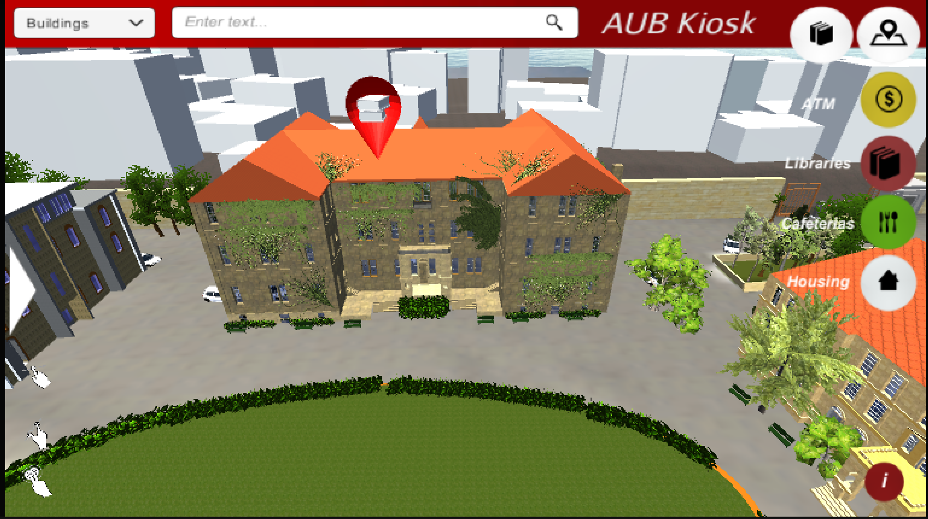

**Use case 5:** Study Places:

The user can click on the book button which will take the user to another scene. In that scene the user has to choose a day, building from a drop down menu and enter a time. Upon clicking search all available classrooms (free for a minimum of 50 minutes) from the search criteria will be shown.

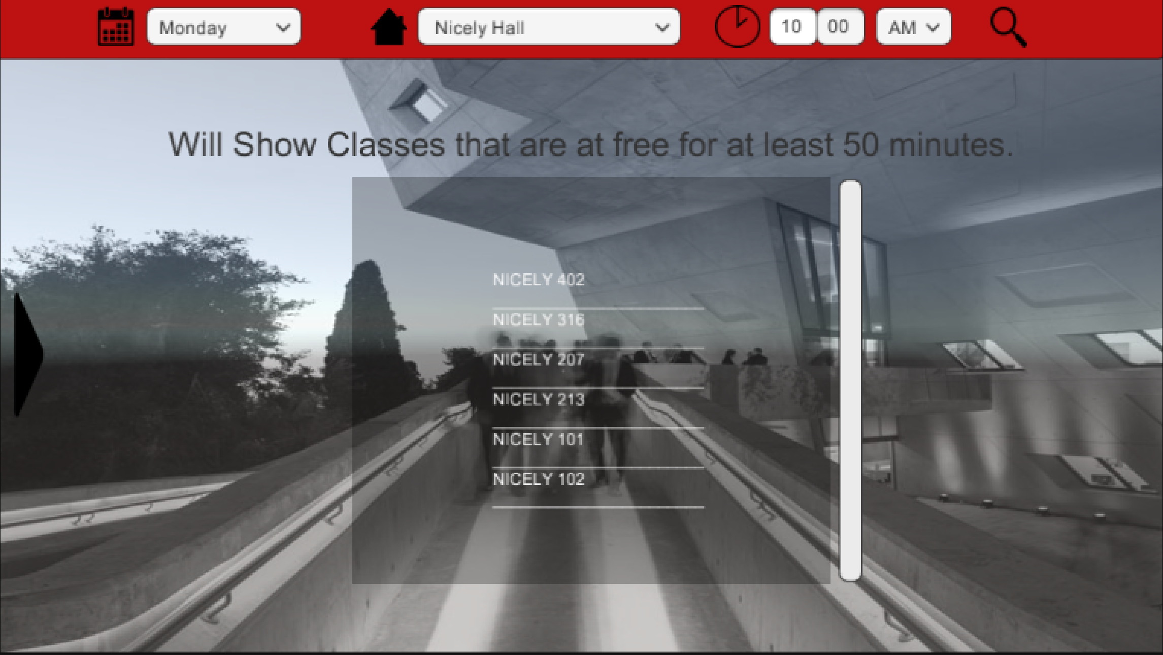

**Use case 6:** Discovering new places outside AUB campus (restricted to areas around AUB):

Clicking on the left button (of the homepage, that is the map) will take the user to another screen which give him a choice to either find a place to eat or discover new places off campus. By touching discover, the user will be taken into a screen with multiple thumbnails of places. Touching any of them will cause a pop up screen with more details about the place.

**Use case 7:** Searching for places to eat around campus:

Clicking on the left button (of the homepage, that is the map) will take the user to another screen which gives them a choice to either find a place to eat or discover a new place off campus. By touching eat, the user will be taken into a screen with multiple thumbnails of places. Touching any of them will cause a pop up screen with more details about the restaurant/cafe.

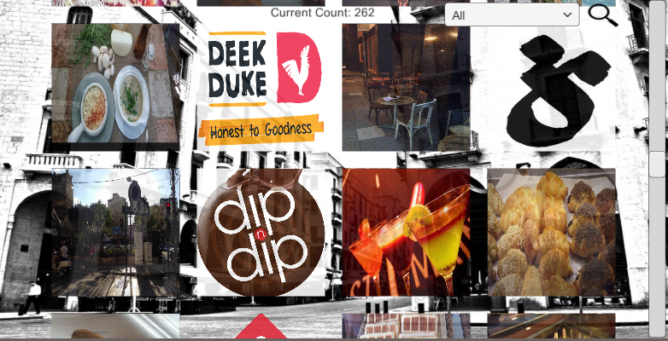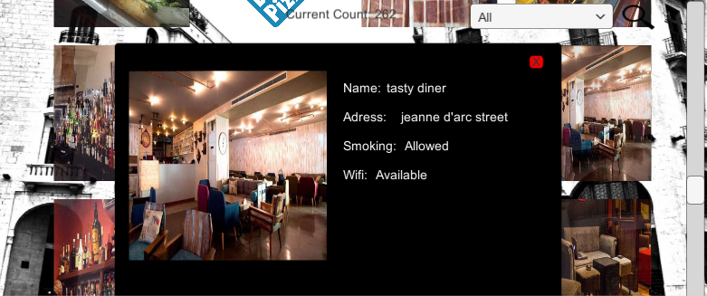

**5. Acknowledgments:**

* Dr. Ahmad Dhaini
* American University of Beirut Facilities Planning and Design Unit
* American University of Beirut Library Archives
* Computer Science technical department
* Physical Plant
* American University of Beirut Faculty of Arts and Sciences 150th Anniversary Conference